Constructors in Java:

a constructor is a block of codes similar to the method. It is called when an instance of the [class](https://www.javatpoint.com/object-and-class-in-java)

is created. At the time of calling constructor, memory for the object is allocated in the memory.

It is a special type of method which is used to initialize the object.

Every time an object is created using the new() keyword, at least one constructor is called.

### **Rules for creating Java constructor**

There are two rules defined for the constructor.

1. Constructor name must be the same as its class name
2. A Constructor must have no explicit return type
3. A Java constructor cannot be abstract, static, final, and synchronized

## **Types of Java constructors**

There are two types of constructors in Java:

1. Default constructor (no-arg constructor)
2. Parameterized constructor

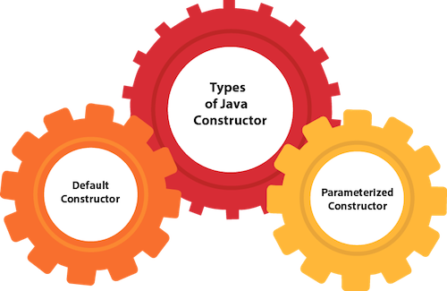

## **Java Default Constructor**

A constructor is called "Default Constructor" when it doesn't have any parameter.

### **Syntax of default constructor:**

1. <class\_name>(){}

## **Example of default constructor**

|  |
| --- |
| In this example, we are creating the no-arg constructor in the Bike class. It will be invoked at the time of object creation. |

1. //Java Program to create and call a default constructor
2. **class** Bike1{
3. //creating a default constructor
4. Bike1(){System.out.println("Bike is created");}
5. //main method
6. **public** **static** **void** main(String args[]){
7. //calling a default constructor
8. Bike1 b=**new** Bike1();
9. }
10. }

**[Test it Now](https://www.javatpoint.com/opr/test.jsp?filename=Bike1" \t "_blank)**

Output:

Bike is created

### **Java Parameterized Constructor**

A constructor which has a specific number of parameters is called a parameterized constructor.

### **Why use the parameterized constructor?**

The parameterized constructor is used to provide different values to distinct objects. However, you can provide the same values also.

### **Example of parameterized constructor**

In this example, we have created the constructor of Student class that have two parameters. We can have any number of parameters in the constructor.

1. //Java Program to demonstrate the use of the parameterized constructor.
2. **class** Student4{
3. **int** id;
4. String name;
5. //creating a parameterized constructor
6. Student4(**int** i,String n){
7. id = i;
8. name = n;
9. }
10. //method to display the values
11. **void** display(){System.out.println(id+" "+name);}
13. **public** **static** **void** main(String args[]){
14. //creating objects and passing values
15. Student4 s1 = **new** Student4(111,"Karan");
16. Student4 s2 = **new** Student4(222,"Aryan");
17. //calling method to display the values of object
18. s1.display();
19. s2.display();
20. }
21. }

**[Test it Now](https://www.javatpoint.com/opr/test.jsp?filename=Student4" \t "_blank)**

Output:

111 Karan

222 Aryan

## **Difference between constructor and method in Java**

There are many differences between constructors and methods. They are given below.

|  |  |
| --- | --- |
| **Java Constructor** | **Java Method** |
| A constructor is used to initialize the state of an object. | A method is used to expose the behavior of an object. |
| A constructor must not have a return type. | A method must have a return type. |
| The constructor is invoked implicitly. | The method is invoked explicitly. |
| The Java compiler provides a default constructor if you don't have any constructor in a class. | The method is not provided by the compiler in any case. |
| The constructor name must be same as the class name. | The method name may or may not be same as the class name. |

# Java static keyword:

The **static keyword** in [Java](https://www.javatpoint.com/java-tutorial)

is used for memory management mainly. We can apply static keyword with [variables](https://www.javatpoint.com/java-variables)

, methods, blocks and [nested classes](https://www.javatpoint.com/java-inner-class)

. The static keyword belongs to the class than an instance of the class.

The static can be:

1. Variable (also known as a class variable)
2. Method (also known as a class method)
3. Block
4. Nested class

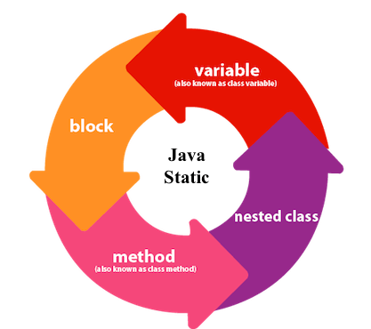

## **1) Java static variable**

If you declare any variable as static, it is known as a static variable.

* The static variable can be used to refer to the common property of all objects (which is not unique for each object), for example, the company name of employees, college name of students, etc.
* The static variable gets memory only once in the class area at the time of class loading.

### **Advantages of static variable**

It makes your program **memory efficient** (i.e., it saves memory).

### **Example of static variable**

1. //Java Program to demonstrate the use of static variable
2. **class** Student{
3. **int** rollno;//instance variable
4. String name;
5. **static** String college ="ITS";//static variable
6. //constructor
7. Student(**int** r, String n){
8. rollno = r;
9. name = n;
10. }
11. //method to display the values
12. **void** display (){System.out.println(rollno+" "+name+" "+college);}
13. }
14. //Test class to show the values of objects
15. **public** **class** TestStaticVariable1{
16. **public** **static** **void** main(String args[]){
17. Student s1 = **new** Student(111,"Karan");
18. Student s2 = **new** Student(222,"Aryan");
19. //we can change the college of all objects by the single line of code
20. //Student.college="BBDIT";
21. s1.display();
22. s2.display();
23. }
24. }

**[Test it Now](https://www.javatpoint.com/opr/test.jsp?filename=TestStaticVariable1" \t "_blank)**

Output:

111 Karan ITS

222 Aryan ITS

### **Another example of a static method that performs a normal calculation**

1. //Java Program to get the cube of a given number using the static method
3. **class** Calculate{
4. **static** **int** cube(**int** x){
5. **return** x\*x\*x;
6. }
8. **public** **static** **void** main(String args[]){
9. **int** result=Calculate.cube(5);
10. System.out.println(result);
11. }
12. }

**[Test it Now](https://www.javatpoint.com/opr/test.jsp?filename=Calculate" \t "_blank)**

Output:125

# this keyword in Java :

There can be a lot of usage of **Java this keyword**. In Java, this is a **reference variable** that refers to the current object.

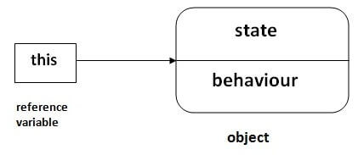

## **Usage of Java this keyword**

Here is given the 6 usage of java this keyword.

1. [this can be used to refer current class instance variable.](https://www.javatpoint.com/this1)
2. [this can be used to invoke current class method (implicitly)](https://www.javatpoint.com/this2)
3. [this() can be used to invoke current class constructor.](https://www.javatpoint.com/this3)
4. [this can be passed as an argument in the method call.](https://www.javatpoint.com/this4)
5. [this can be passed as argument in the constructor call.](https://www.javatpoint.com/this5)
6. [this can be used to return the current class instance from the method.](https://www.javatpoint.com/this6)

**Suggestion:** If you are beginner to java, lookup only three usages of this keyword.

# Usage of Java this keyword

#### **Solution of the above problem by this keyword**

1. **class** Student{
2. **int** rollno;
3. String name;
4. **float** fee;
5. Student(**int** rollno,String name,**float** fee){
6. **this**.rollno=rollno;
7. **this**.name=name;
8. **this**.fee=fee;
9. }
10. **void** display(){System.out.println(rollno+" "+name+" "+fee);}
11. }
13. **class** TestThis2{
14. **public** **static** **void** main(String args[]){
15. Student s1=**new** Student(111,"ankit",5000f);
16. Student s2=**new** Student(112,"sumit",6000f);
17. s1.display();
18. s2.display();
19. }}

[**Test it Now**](https://www.javatpoint.com/opr/test.jsp?filename=TestThis2)

**Output:**

111 ankit 5000.0

112 sumit 6000.0

#### **Program where this keyword is not required**

1. **class** Student{
2. **int** rollno;
3. String name;
4. **float** fee;
5. Student(**int** r,String n,**float** f){
6. rollno=r;
7. name=n;
8. fee=f;
9. }
10. **void** display(){System.out.println(rollno+" "+name+" "+fee);}
11. }
13. **class** TestThis3{
14. **public** **static** **void** main(String args[]){
15. Student s1=**new** Student(111,"ankit",5000f);
16. Student s2=**new** Student(112,"sumit",6000f);
17. s1.display();
18. s2.display();
19. }}

[**Test it Now**](https://www.javatpoint.com/opr/test.jsp?filename=TestThis3)

**Output:**

111 ankit 5000.0

112 sumit 6000.0